UNIQUE DAY TOUR HA NOI - CAT BA ISLAND – LAN HA BAY
Nestled in the Gulf of Tonkin, Lan Ha Bay not only appeals to tourists by its majestic scenery but also charms them with the harmony between nature and people, long-lasting cultural values, and a rich biological system .Next door, Cat Ba Island is a natural haven featuring a lush national park, age-old fishing villages, and untouched beaches. Together, they create a captivating retreat, offering a slice of calm away from the bustling world.
A day trip to Cat Ba Island & less touristy area of Lan Ha Bay is an ideal trip for those who seek for truly experience but have limited time. The SERENITY CRUISE will not only bring you a journey in comfort & luxury but Ignite your adventurous spirit with kayaking, swimming, biking & more
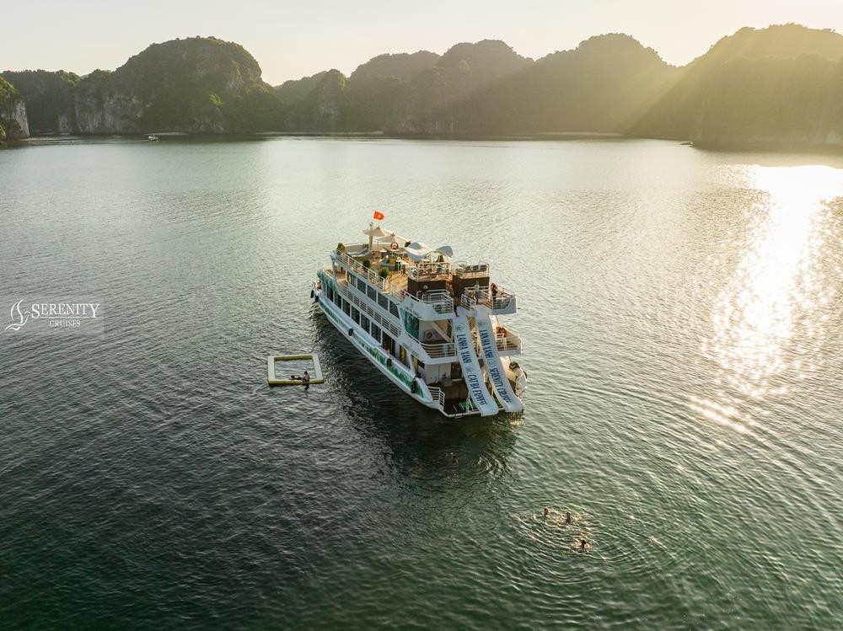

Highlights:
- An exclusive one-day journey from Hanoi to Cat Ba and Lan Ha Bay awaits
- Luxury cruise features spacious areas, a chill rooftop bar, two restaurants, water slide floating swimming pool …
- Unique route unveils the wild, untouched beauty of Lan Ha Bay.
- Ignite your adventurous spirit with kayaking, swimming and more
- Professional & enthusiastic team

Itinerary:
7:00 – 7:30 Get picked up at your hotel in Hanoi Old Quarter, departure to Cat Ba Island 10:15 – 10:30 Reach Cat Ba Island, drive on a scenic coastal from Cai Vieng Port to Beo Harbour
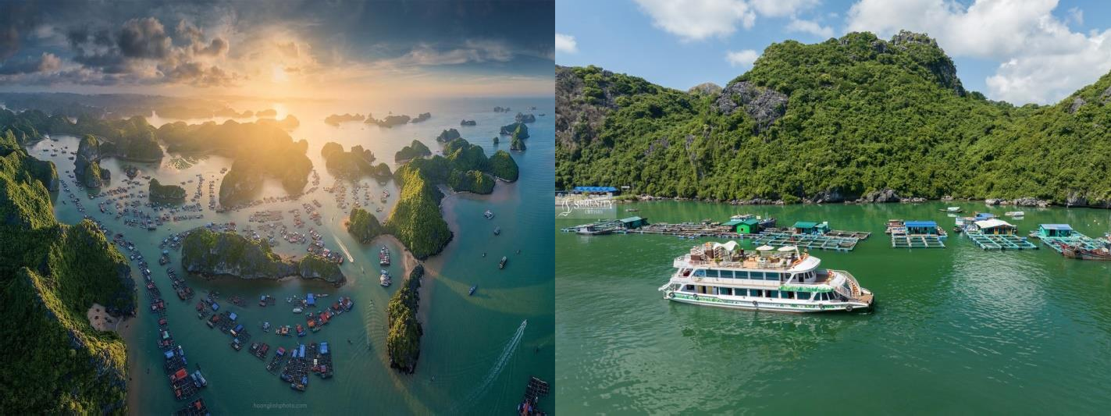

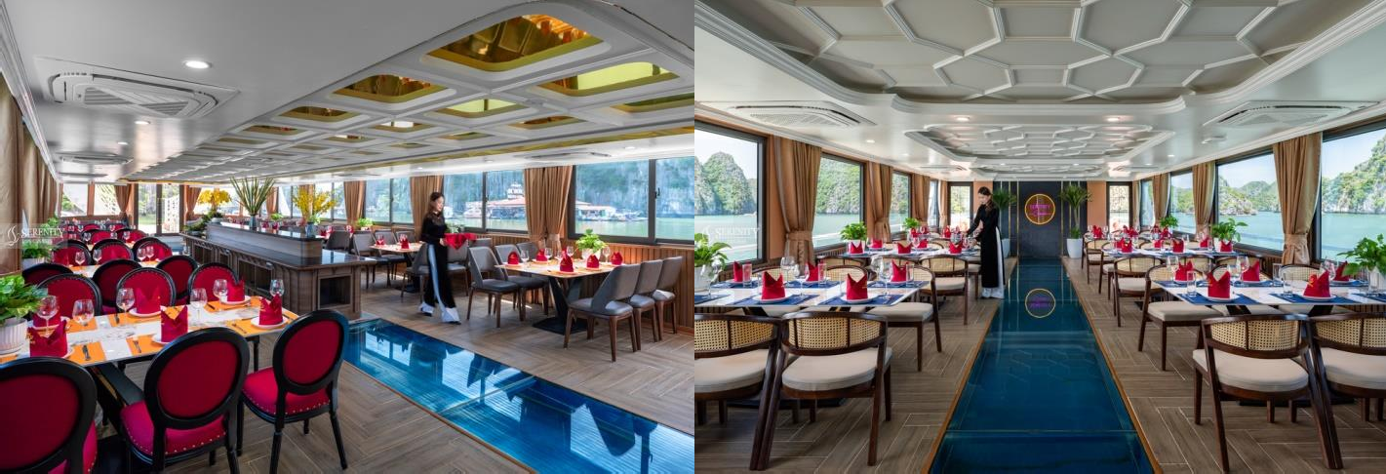
11:00 Warmly welcome to SERENITY CRUISES! While enjoying welcome drink, our tour guide will provide key information about the cruise, itineraries, and other notes.

Our captain steers the cruise slowly, and the poetic scenery of Cai Beo ancient fishing village constantly appears with floating houses lying along the mountainside. You will be surprised at the peaceful beauty of this 7,000-year-old village.
The cruise moves further into the core of bay where you can't help but be amazed by the gift of Mother Nature: a large bay area, the phenomenal emerald water embracing hundreds of rocky islands of various sizes and shapes.
11:30 Savor a delicious lunch (Buffet lunch is served for group from 40 guests)
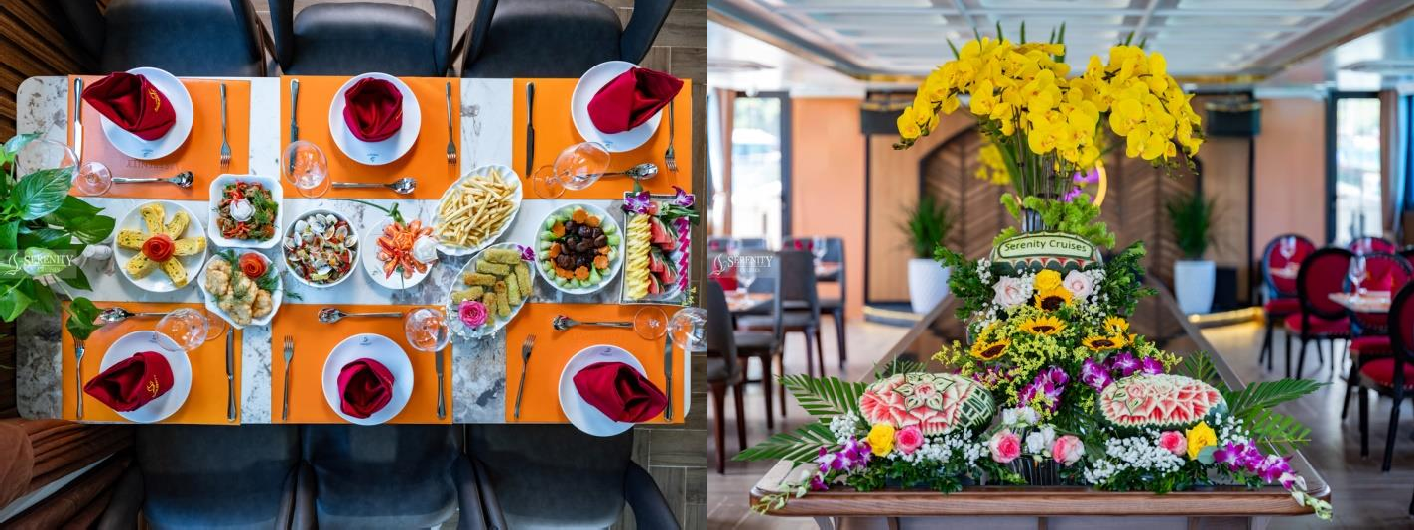
13:00 After lunch, the cruise sails to Viet Hai Port. Disembark and head to the pier, where you will take electric car/bicycle to the ancient Viet Hai Village. Experience a unique fish-foot massage, stroll through well-preserved traditional houses, or engage in conversations with local residents for a truly memorable experience.


14:30 KAYAKING - SWIMMING
Our Captain and Tour Guide will choose the best stop for the group to experience interesting activities: Swimming in the middle of the sea, boat- jumping, sliding down from the top deck to cool water, kayaking,….

(We highly recommend that you wear a life jacket when swimming/ kayaking/playing with water slide…for a safe journey)
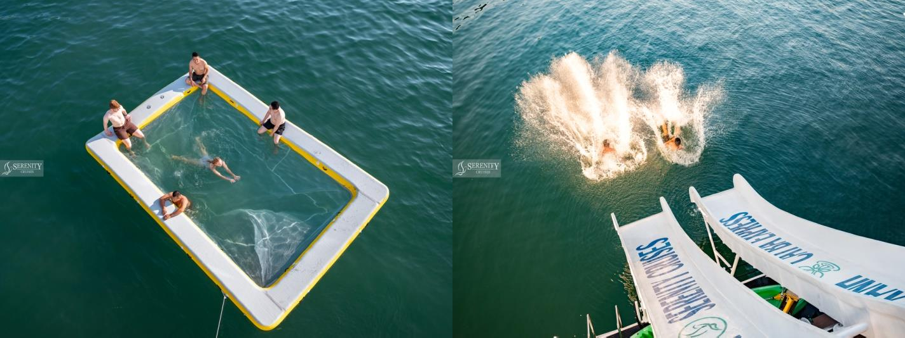
15:40 The boat begins its journey back to Beo Pier. It is perfect time to relax yourself on the top deck with a cup of ordered drink.
16:15 Small sunset party is served with fresh fruit, biscuits & tea.
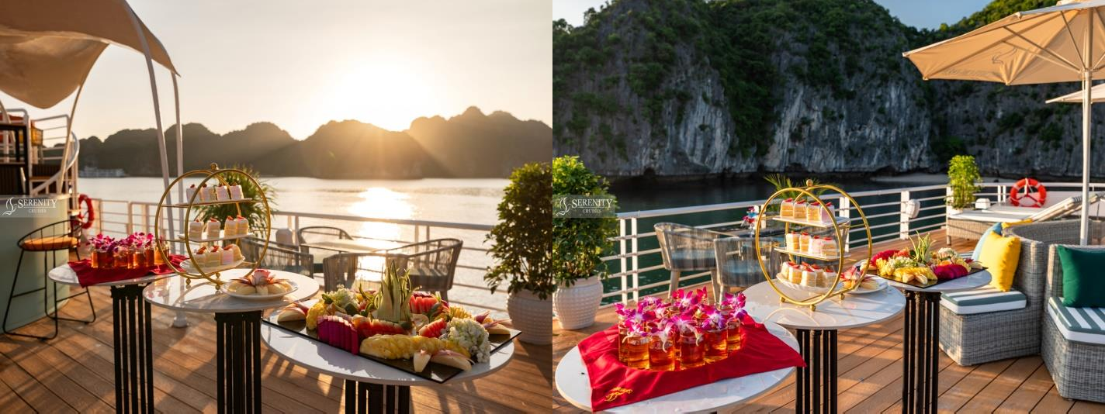
16:45 Return to Beo Dock, say ”Goodbye” Lan Ha Bay & Serenity Cruise team, and Get on the bus back to Ha Noi.
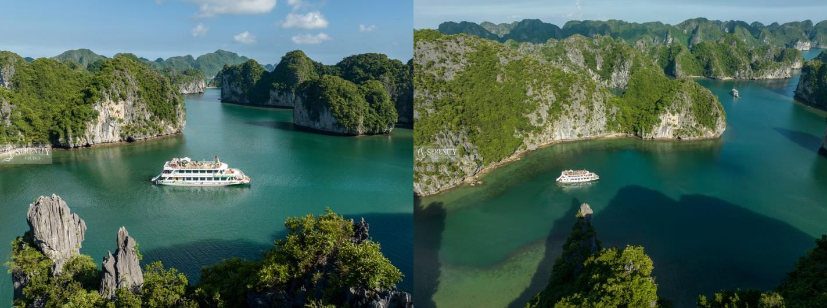

20:30 Arrive at Hanoi Old Quarter, end of unforgettable journey.

Important Notes:

- Cruise itinerary might be changed due to weather and other conditions without prior notice
- Swimming or kayaking activity may be not possible due to bad weather. Unused services are not subjected to a refund
- Lunch on the cruise is served with seafood, meats & Vietnamese rice . Request for food vegetarian should be informed at least 1 day before departure
- Guests are requested to submit their personal information at least 24 hours prior to the departure for the travel declaration to the port authority, including: Full name, Birthday, nationality,…
- Method of payment: guests pay in advance before check in

Inclusions:
- Round trip transfer Ha Noi – Cat Ba Island
- Vietnamese/ English speaking guide on boat
- Welcome drink
- Entrance ticket, sightseeing ticket
- Lunch on cruise
- Experienced and professional tour guide
- Kayak, swimming
- Free 1 bottle of water

Exclusions:
🗶 Tips for tour guide/ Staff on boat
🗶 Drinks at bar

What should you bring?
- Swim suits
- Hat
- Suncream
- Personal towel
- Water-proof phone pouch

