VUNG TAU FULL DAY TRIP
GROUP SIZE: 25 pax
PICK UP: 07:00 – 07:30 AM (the time of pick up depends on customer’s hotel/ accommodation’s exact position).
RETURN: 17:30 – 18:00 PM
ROUTE: HCMC – VUNG TAU – HCMC
Highlight:
- Swim and relax at Thuy Van Beach
- Experience the sacred ambiance of Whale Temple and the religious life of local fishermen
- Visit and climb inside the Jesus Christ Statue
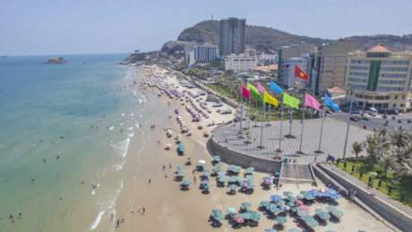
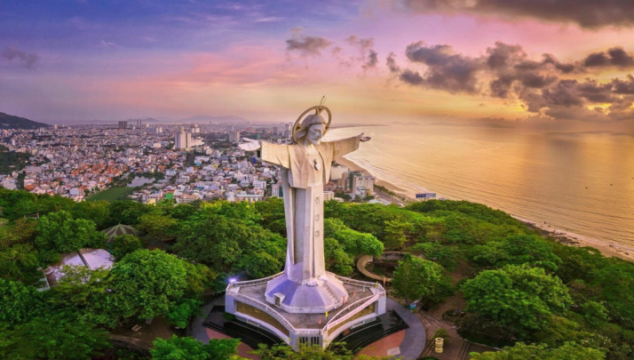

Itinerary:
07:30 am, pick you up from hotel depart for Vung Tau.
09:00 am, on arrival Vung Tau and leisure time at Thuy Van beach (Back beach) - one of the nicest beaches in Vietnam with the shore runs for almost 10km, full with fine sands and white waves. Authentic Vietnamese lunch is served at a local restaurant.
In the afternoon, visit the Jesus Christ Statue, Thang Tam Temple (Whale Temple), Bach Dinh (a.k.a.Villa Blanche in French or White Palace in English), Cape Nghinh Phong. Taking a short break. Back to Ho Chi Minh City around 18:00pm. End trip.
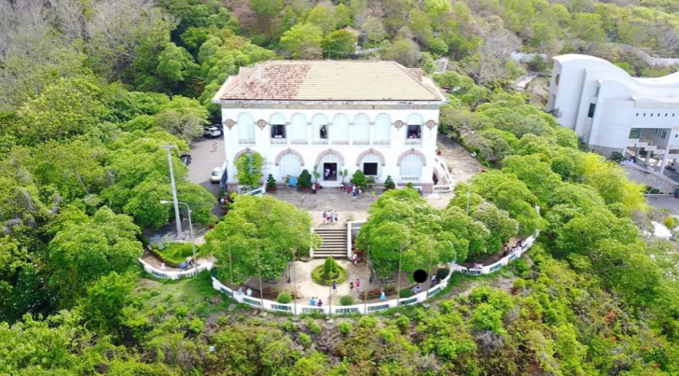
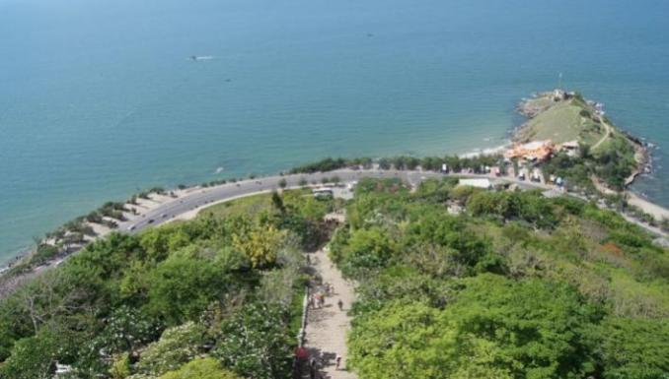

***Please note: Drop off time is subject to traffic, weather...so the finished time could be later than expecting.

Tour price includes:
- A/c van/car for pick up and transfers per program
- English speaking guide for the whole trip
- Lunch
- Entrance fee
- Mineral water (1 bottles/pax)
Tour price excludes:
- Travel insurance
- Drinks & other meals not mentioned in the program.
- Tipping is at customer’s discretion
NOTE:
- Pick up at meting point (177 De Tham street, Pham Ngu Lao ward, district 1) at 07:30 AM
- Pick up and transfer to the centrally located hote/accommodation in Dist 1, Ho Chi Minh City:
+ Time pick up is 7:00 – 7:15 AM, customer must be present at the lobby on that time. (the time of pick up depends on your accommodation’s exact position).
+ VN Lotus Travel just offers pickup service to customers at the hotels located in the center of District 1, in more detail consisting of streets: Lý Tự Trọng, Lê Thánh Tôn, Trương Định, Nguyễn An Ninh, Phan Chu Trinh, Lưu Văn Lang, Lê Anh Xuân, Đồng Khởi, Nguyễn Huệ, Thi Sách, Thủ Khoa Huân, Thái Văn Lung, Mạc Thị Bưởi, Hồ Huấn Nghiệp, Nguyễn Thái Bình, Lê Thị Hồng Gấm, Bùi Thị Xuân, Sương Nguyệt Anh and Ký Con.
+ The exact pickup time in the above prescribed ranges varies according to the position of the customers’ hotels or the pickup points required. Because of the traffic rule, the hotels/accommodations which located in the alley will be not served the pickup service.
- We are not responsible for your lateness.
- Children must be accompanied by an adult. Child rate applies only when sharing with 2 paying adults, otherwise they will be subject to the adult rate. A surcharge maybe applied to the bookings with 2 or more children.
- Infant rates apply provided they do not occupy a seat and the tour inclusions. Please advise the supplier if you have from 1 infant at time of booking.

